Pace Name__________________________________
English 9CP Date_______________________________
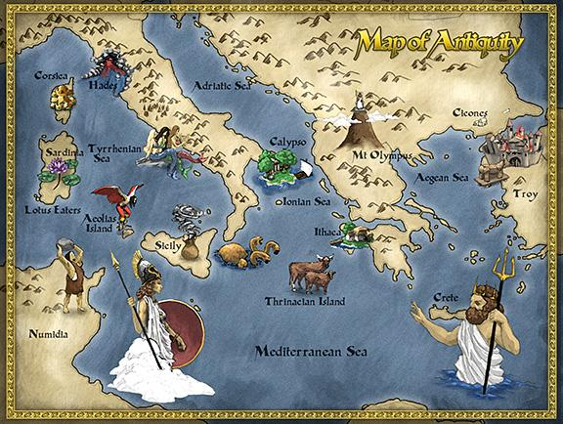
Block______
The Odyssey
by Homer
Part One

Directions: You will need to set up a piece of notebook paper in MLA Format. Answer each question below in a clear and complete sentence. You will lose points if your answer is not in complete sentence form and if it does not clearly answer the question. When possible cite specific evidence (line numbers, page numbers).

Homer’s Invocation (page 751) is much like a prologue or introduction to the story. Answer the following questions on your own notebook paper in MLA format. Your answers MUST be in complete sentences!!

- What is an invocation?
- Homer opens this epic poem with an invocation to whom? Why; what’s the point in this?
- He describes Odysseus as “the wanderer” and tells of how he seen much while on this journey. What is another name for a long journey?
- According to Homer’s invocation, who is responsible for the death of Odysseus’ crew?
- As this story epic begins, we learn from Homer’s invocation that Odysseus has been held captive. By whom?

Books 1-4: Tell of Odysseus’ son, Telemachus. He has been searching the Mediterranean world for his father, who has never returned from the ten year Trojan War. When we first meet Odysseus in Book 5, he is a prisoner of the beautiful Calypso. He has spent seven of these years on Calypso’s island.

- Which goddess helps Odysseus throughout his journey?
- How is it that Odysseus is capable of escaping the charms of Calypso?

Part One – The Wanderings
Calypso, the Sweet Nymph (pages 752-754)

- We learn that Hermes, the messenger god, is getting ready to go run an errand, certainly for one of the gods on Mount Olympus. We learn that he is not only the messenger god, but also capable of doing what?
- A Homeric simile, also called an epic simile, is a detailed comparison in the form of a simile that is many lines in length. Homeric Similes are used typically in epic poetry to intensify the heroic stature of the subject and to serve as decoration.
What is Hermes’ flight compared to in the lines 39-47?
- When we first see Calypso, what is she doing (two things)?
- Why has Hermes traveled to Calypso’s island?
- How is Calypso’s island described in lines 64-65?
- When Hermes first sees Odysseus, what is he doing?
- Why is Odysseus so wracked with dismay?
- Irony is a figurative device used in literature, either in spoken or written form, in which the real meaning is concealed or contradicted by the literal meanings of the words. Irony occurs when there is more than meets the eye, or something is not quite as it seems. What is ironic about what Calypso says to Odysseus in lines 88-91?
- A kenning is a concise compound or figurative phrase replacing a common noun. Examples of kennings are: whale-road = the sea, blood-sucker = vampire,
sky’s jewel = the sun, giver of education = teacher. Kennings are formed one of three ways: prepositional phrase (giver of education), possessive phrase (sky’s jewel), or a hyphenated phrase (blood-sucker).
What kenning does Calypso use to describe (re-name) Odysseus in line 101?
- Calypso foreshadows Odysseus’ future troubles. What does she say will happen to him once he leaves her island?
- Calypso is making reference to someone when she says, “that bride for whom you pine each day.” Who is she talking about? What does this tell us about Odysseus?
- Why does Odysseus make Penelope seem so bleak and uninteresting when he describes her to Calypso in lines 113-118?
- After leaving Calypso’s island Odysseus encounters the wrath of Poseidon. What happens to him?

“I am Laertes’ Son…” (pages 756-758)

- Who finds Odysseus?
- Where is he?
- An important element of Greek customs is revealed at the top of page 756. What do we learn about guests?
- Why does Odysseus cry after the minstrel sings his song?
- Once King Alcinous asks Odysseus to finally identify himself, the true odyssey begins. Odysseus tells retells his story (of the past events that have happened so far on his journey home). In essence this whole story (The Odyssey) is a flashback. In history, film, television and other media, a flashback (also called analepsis) is an interjected scene that takes the narrative back in time from the current point the story has reached. Flashbacks are often used to recount events that happened prior to the story’s primary sequence of events or to fill in crucial back story.
In this flashback, we learn that Odysseus has been detained by Calypso and another goddess. What is the other goddesses’ name?
- The theme of this entire epic poem is expressed to us by Odysseus in lines 143-146. What is it that Odysseus longs for?
- One of the first places that Odysseus and his crew stop is at the island of Ismaros. Here, Odysseus, who considers himself and great leader, blames his unruly crew for the Cicones’ attack. What goes wrong according to Odysseus’ retelling of the events?
- Does their insubordination reflect unfavorably on Odysseus? Why or why not?
- The Cicones come back on horseback. The following quote describes their arrival at the battle site. It is an example of what literary device?

“They came with dawn over that terrain like the leaves and blades of spring.”

- Personification is a figure of speech in which abstractions, animals, ideas, and inanimate objects are endowed with human form, character, traits, or sensibilities. A common example of personification is when one refers to a car as “she.” Another example of personification is “the wind shrieked through the window.”
Odysseus says, “six benches were left empty in every ship that evening when we pulled
away from death.” What is being personified in this excerpt?
- Another example of a kenning is found in line 179. What is it?
- Odysseus does not make it home at this time. He says that he rounded “Malea and the current took me out to sea.” He says they drifted for ______ days.

The Lotus Eaters (page 758)
- What is the Lotus? What does it cause to happen?
- Odysseus forces his men back onto the ship and ties them down. What does this action tell you about him as a leader?

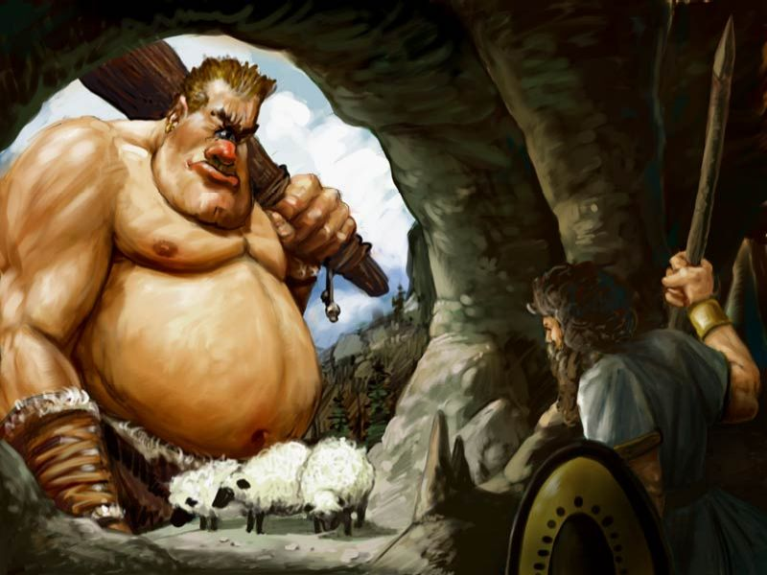
The Cyclops (pages 760-770)

- Who is Polyphemus related to?
- When we first meet Polyphemus he is going about his daily/nightly business. What is he doing?
- In lines 242-245, Polyphemus asks Odysseus and his men several questions. What does the Cyclops seem to be trying to figure out?
- The following quote from The Odyssey is an example of ____________________.
“We felt a pressure on our hearts, in dread
Of that deep rumble and that mighty man.”
- Odysseus gives Polyphemus a sort of warning in lines 256-261. What did you learn about in an earlier summary that explains why Odysseus would give Polyphemus this warning?
- Shockingly, Polyphemus replies that Odysseus is a “__________________________.”
- It becomes obvious that Cyclops don’t seem to care or worry about the gods. Why do you think this is?
- Why is Polyphemus interested in Odysseus’ ship?
- What does Odysseus do when faced with Polyphemus’ prying question?
- Out of nowhere, Polyphemus does something shocking. What is it that he does?
- Even though this angers Odysseus, why doesn’t he act immediately against the giant, one-eyed monster?
- What does this prove about Odysseus?
- What is a simile? (Look in the back of your literature if you do not already know.)
- Copy down two similes from the episode in which Polyphemus proves himself to be a cannibal.
- After thinking things through, Odysseus comes up with a plan. What is the plan?
- How is it that Odysseus is able to get the giant, Polyphemus, off guard?
- What does Odysseus tell the Cyclops his name is?
- What do Odysseus and his men do to Polyphemus?
- Odysseus compares this graphic image to an everyday image. What analogy is set up here?
- How does Odysseus’ smart thinking prove to have been successful?
- Homer says, “death sat there huge.” What literary device is being used here?
- How does Odysseus plan to escape?
- Polyphemus says to his favorite (lead ram), “sweet cousin ram, why lag behind the rest in the night cave? You never linger so, but graze before them all…Can you be grieving over your Master’s eye….Oh, had you brain and voice to tell where he may be now, dodging all my fury!”
What literary device is being used here?
- Once successfully out of the cave. The men steal the sheep. Back on their ship, Odysseus shows another of his tragic weaknesses. What flaw does he exhibit here?
- “Eater of guests” is a ______________________.
- What does Polyphemus hurl at Odysseus’ ship? What almost happens as a result?
- Again, although his crew begs him not to, Odysseys exhibits another flaw. Which flaw does his show here?
- Who is the god of earthquakes?
- Polyphemus curses Odysseus by praying to his father, Poseidon. What does he pray will happen to Odysseus?
- This is an example of ______________________________.

SIGN THE PLEDGE.
DO NOT SHARE YOUR WORK!!

